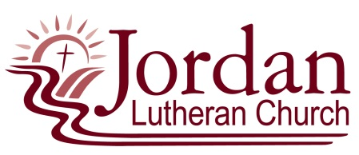
Sermon Notes
Name: _____________________________________________ Worship Date: ___________________

- Lessons used in worship: (OT, Psalm, Epistle/2nd Lesson, Gospel)

- Describe in a sentence or two what the sermon was about:

- What did I learn about God?

- How can I use the sermon message in my life?

- What did you like about the sermon?

- What are some things (if any) that you did not understand in the sermon?

- Other questions/concerns or things that you are curious about in the worship service?

Please return the completed sermon notes to Pastor Dody. Thank you.

(revised 7/13/2022)

