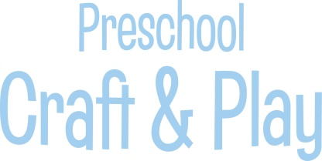

Engineer joy as a Station Leader at Rocky Railway VBS!
- Start your VBS adventure at a special staff training session – we’ll make sure it’s fun.
- Choose from the fun Imagination Station experiments and craft options for each day of VBS.
- Have fun testing the crafts ahead of time – you’ll love the one-of-a-kind crafts as much as the kids do.
- Lead kids at Craft & Play each day.
- Use the daily Bible Point often, and hear kids shout an enthusiastic “Trust Jesus!”
- Help kids celebrate that they can trust Jesus through all the twists and turns of life!

