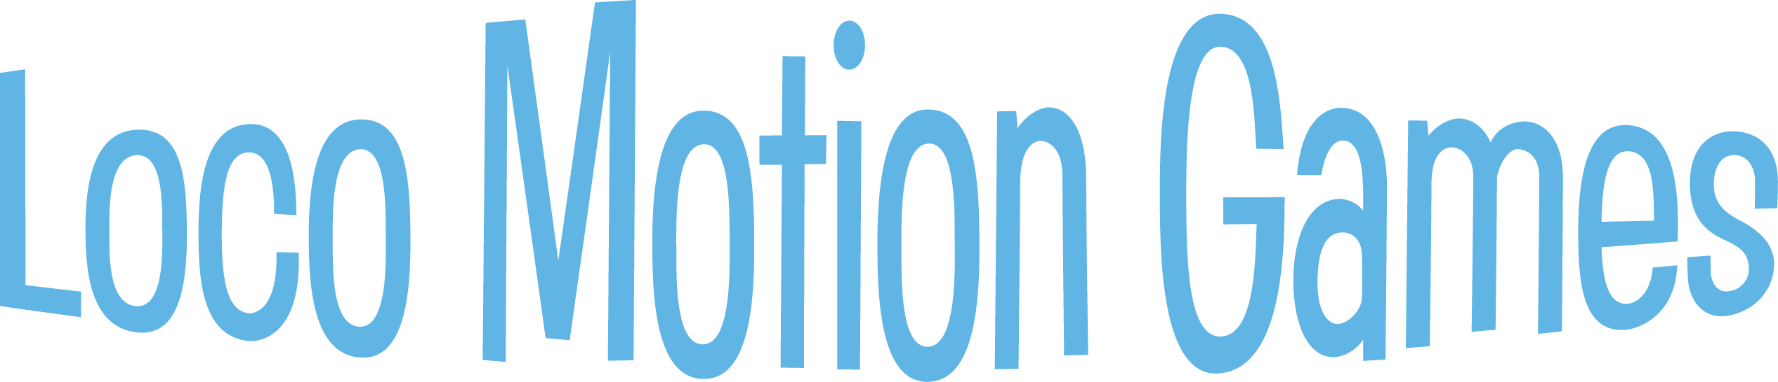
Engineer joy as a Station Leader at Rocky Railway VBS!
- Start your VBS adventure at a special staff training session – we’ll make sure it’s fun.
- Help build enthusiasm for Operation Kid-to-Kid. Starting on Day 2, each day includes a game option connecting to the Operation Kid-to-Kid mission project.
- Check out all the awesome game options in the Loco Motion Games Leader Manual, and choose two games for each day.
- Lead crews in the fun at sessions of Loco Motion Games each day.
- Help kids learn they can trust Jesus!

